**Ansh Ranjan  
Azure Data**

**EXERCISE 4: Azure Synapse Analytics**

**TASK 1: Deploy a sample Azure Synapse Analytics workspace**

1. Go to Azure Synapse Analytics > Create > Enter Details   
   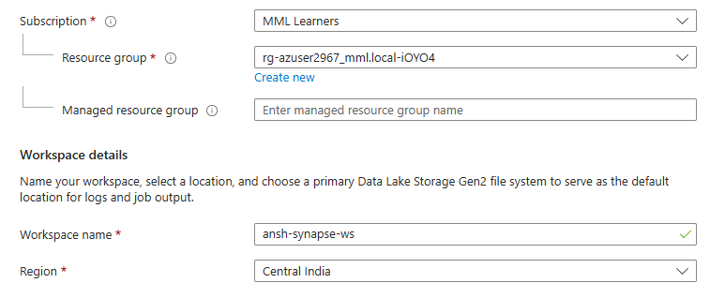
2. Select or create a Dala Lake Gen 2 storage    
   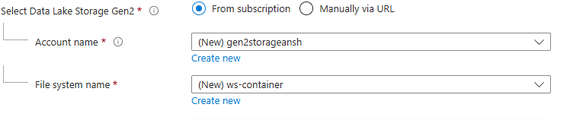
3. Once again set a sql server admin login and password
4. Click on Review and Create

**TASK 2: Load a sample dataset and perform basic queries**

1. Upload a dataset in your container created   
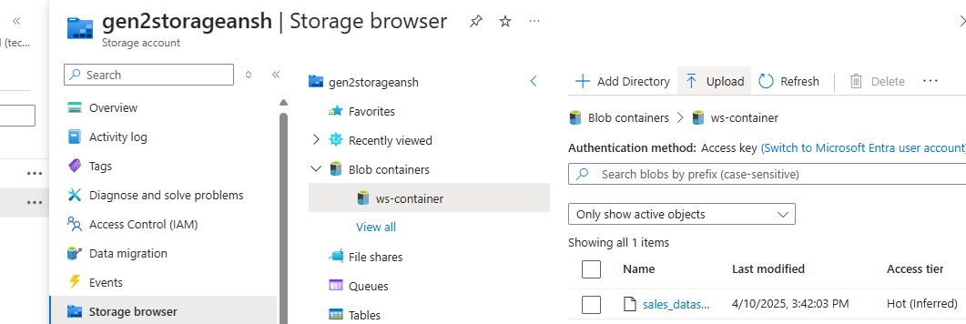

1. Go to Data side tab > browse to your container > right click on ingested data > Select top 100 rows  
   A screenshot of a computer

   AI-generated content may be incorrect.
2. This will write a sql script for you to display first 100 rows of your ingested dataset.  
   A screenshot of a computer code

   AI-generated content may be incorrect.
3. You can execute the query using the serverless sql pool provided while creating the workspace.
4. However due to firewall limitations we are unable to use either serverless sql pools of dedicated sql pools in this azure account.

**TASK 3: Document Azure Synapse Key Benefits and Use cases**

**Azure Synapse Key Benefits:**

1. **Unified Analytics Platform**: Combines big data and data warehousing into a single platform, allowing for streamlined data analysis.
2. **Scalability**: Offers on-demand scalability, enabling you to handle large datasets and workloads without managing infrastructure.
3. **Integrated AI and Machine Learning**: Built-in integration with Azure Machine Learning and cognitive services to run advanced analytics and AI models.
4. **Real-time Analytics**: Supports real-time data streaming and analytics, providing insights with minimal delay.
5. **End-to-End Security**: Features robust security with encryption, firewalls, threat protection, and compliance with industry standards.
6. **Optimized Query Performance**: Leverages in-memory processing, parallel query execution, and caching for faster query performance.
7. **Serverless and Provisioned Models**: Offers both serverless querying and provisioned resources, allowing cost flexibility.
8. **Easy Integration with Other Azure Services**: Seamlessly integrates with tools like Power BI, Azure Data Factory, and Azure Databricks for enhanced data processing and visualization.

**Azure Synapse Use Cases:**

1. **Data Warehousing**: Store, manage, and analyze large datasets with high-performance query capabilities.
2. **Real-Time Analytics**: Process and analyze real-time streaming data for quick decision-making.
3. **Big Data Processing**: Work with massive amounts of unstructured and structured data using Spark and other big data tools.
4. **Business Intelligence**: Integrate with Power BI for advanced reporting, dashboards, and visual analytics.
5. **Advanced Analytics and AI**: Run predictive analytics and machine learning models directly within the platform.
6. **ETL/ELT Pipelines**: Build data pipelines using Azure Data Factory to move, transform, and load data for further analysis.
7. **Data Lakes**: Store raw, unstructured data in Azure Data Lake and process it using Synapse's integrated tools.
8. **Cost-Effective Storage**: Archive historical data with minimal cost by utilizing the platform's tiered storage model.